Please answer all the questions accordingly and submit the solution.

**Problem-1**

**A company needs to generate a report that displays the total sales for each month of the year, along with the percentage of sales for each month out of the total sales for the year. They want to use a Common Table Expression (CTE) to simplify the query.**

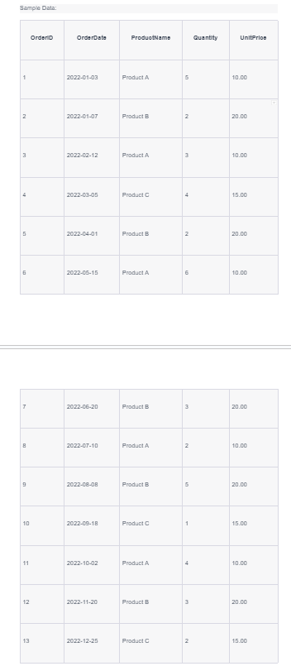

**Ques-1 Write a SQL query to display the total sales for each month of the year, using a Common Table Expression (CTE)**

**Ques-2 Write a SQL query to display the percentage of sales for each month out of the total sales for the year, using a Common Table Expression (CTE)**

**Problem-2**

**The HR department of a company wants to generate a report that shows the top three employees in each department based on their salaries. The report should include the employee's name, department name, and salary.**

**Ques-Create a CTE that groups the employees by department and orders them by salary in descending order.**